**Cross Platform App Development Lab Experiment No.7**

**Aim:** Implementing multiple screen navigation and nested navigation using solutions provided by React Navigation and .NET MAUI.

**Objectives:**

1. Implement multiple screen navigation in a React Native application.
2. Explore the solutions provided by React Navigation for nested navigation.
3. Implement multiple screen navigation in a .NET MAUI application.
4. Utilize .NET MAUI's solutions for nested navigation.

**Theory:**

**- React Navigation:**

- Library for navigation in React Native applications.

- Supports stack, tab, drawer, and other types of navigators.

- Allows easy management of multiple screens.

- Nested Navigation in React Navigation:

- Involves navigating within screens of a navigator.

- Achieved using nested navigators like Stack Navigator within Tab Navigator.

**- .NET MAUI Navigation:**

- .NET Multi-platform App UI (MAUI) framework for cross-platform app development.

- Supports navigation patterns similar to Xamarin Forms.

- Offers navigation containers and pages for screen navigation.

- Nested Navigation in .NET MAUI:

- Involves navigating between pages and utilizing navigation containers.

- Hierarchical navigation structure for managing nested navigation.

**Requirements:**

- React Native development environment for React Navigation.

- .NET MAUI development environment for .NET MAUI navigation.

**Tools:**

- React Navigation library for React Native.

- Visual Studio or Visual Studio Code for .NET MAUI development.

**Implementation/ Code:-**

import { StyleSheet, Text, View } from 'react-native'

import React from 'react'

import { createNativeStackNavigator } from '@react-navigation/native-stack';

import { NavigationContainer } from '@react-navigation/native';

import HomeScreen from './screens/HomeScreen';

import PickUpScreen from './screens/PickUpScreen';

import CartScreen from './screens/CartScreen';

import LoginScreen from './screens/LoginScreen';

import RegisterScreen from './screens/RegisterScreen';

import ProfileScreen from './screens/ProfileScreen';

const StackNavigator = () => {

  const Stack = createNativeStackNavigator();

return (

  <NavigationContainer>

    <Stack.Navigator>

      <Stack.Screen name="Login" component={LoginScreen} options={{headerShown:false}}/>

      <Stack.Screen name="Home" component={HomeScreen} options={{headerShown:false}}/>

      <Stack.Screen name="PickUp" component={PickUpScreen} options={{headerShown:false}}/>

      <Stack.Screen name="Cart" component={CartScreen} options={{headerShown:false}}/>

      <Stack.Screen name="Register" component={RegisterScreen} options={{headerShown:false}}/>

      <Stack.Screen name="Profile" component={ProfileScreen} options={{headerShown:false}}/>

    </Stack.Navigator>

  </NavigationContainer>

)

}

export default StackNavigator

const styles = StyleSheet.create({})

- Used stack navigator for navigating from one screen to another.

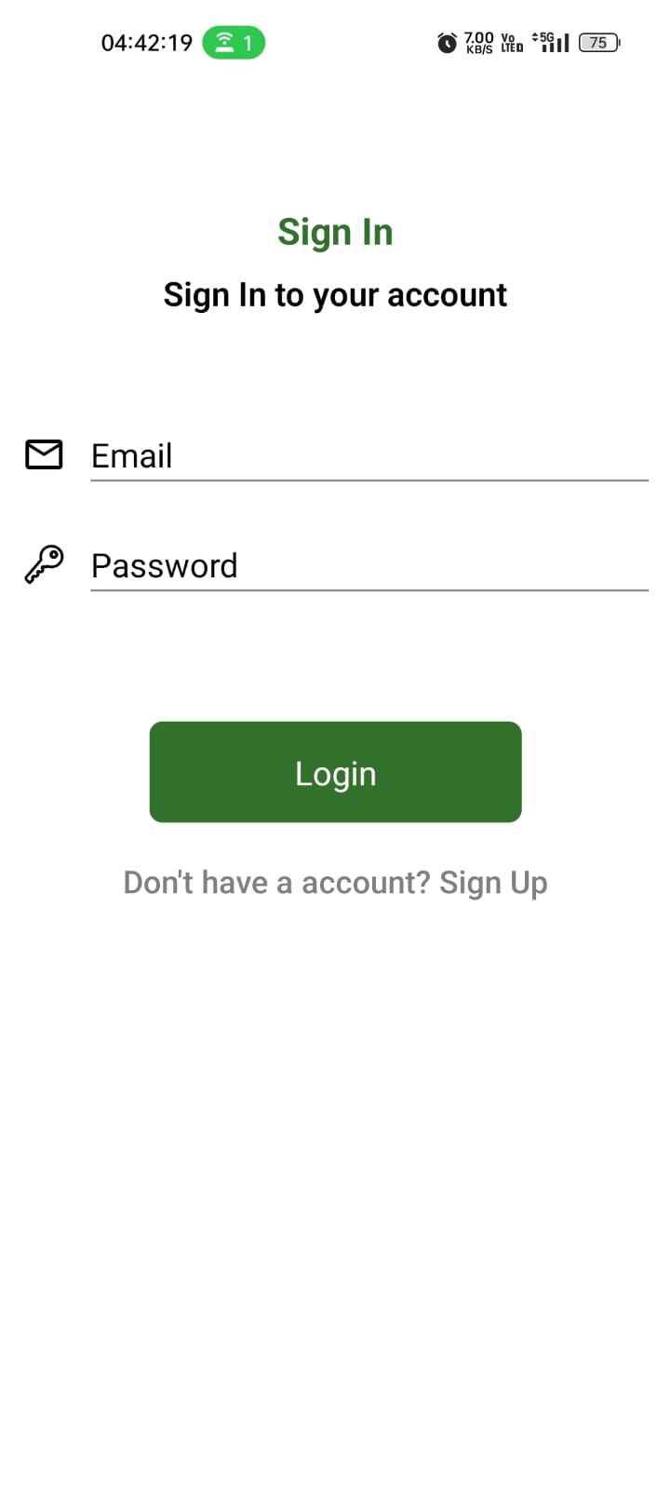 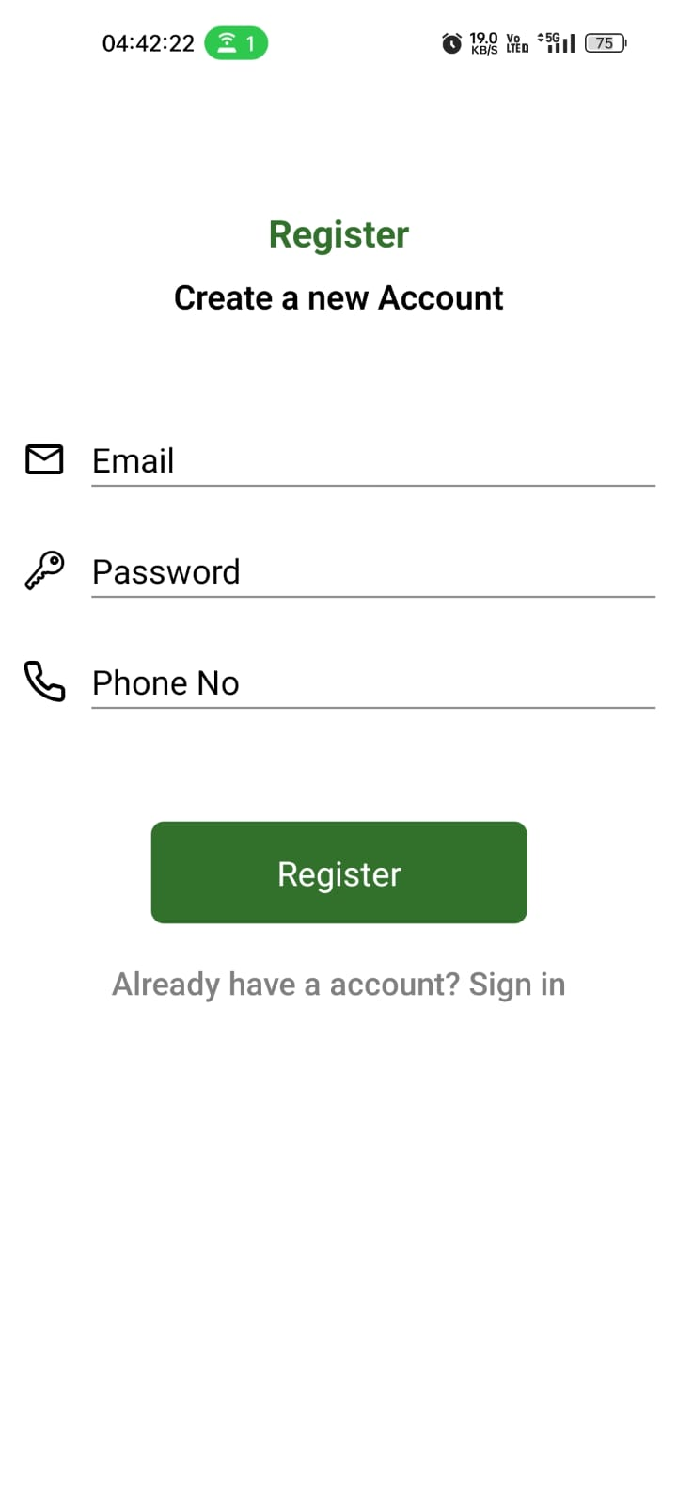

- First we, clicked on **Don’t have a account? Sign Up** then we are navigated to another page that is **register page**

**Conclusion:**

By implementing multiple screen navigation using React Navigation for React Native built-in navigation solutions, we enhance the user experience and provide a structured flow within the applications.

**References:**

1. React Navigation documentation:https://reactnavigation.org/docs/getting-started

2. .NET MAUI documentation: https://docs.microsoft.com/en-us/dotnet/maui